Access Notes: Kingston Arts Council
Last edited: March 31, 2024
Created by Erin Ball courtesy of KEYS
Template by Erin Ball and Maxime Beauregard

Address: 370 King St W #115, Kingston, ON K7L 2X4, located on the first (bottom) floor inside the Tett Centre

Email: info@artskingston.ca

Phone: 613-546-2787

Hours: 10am – 4pm, Monday through Friday

WIFI: Free Wi-Fi is available. The login information is posted in the office and staff can assist.

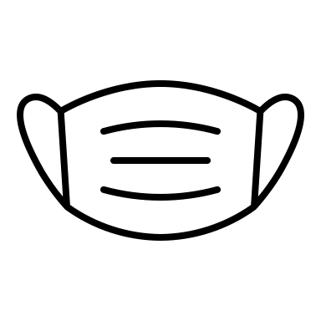Mask Policies: Face masks are not mandatory though staff are happy to wear them. N95 masks are available. Sanitizer is available. The covid and sickness policy is to stay home.

Childcare Policies: Children are welcome in the space. Colouring pages and crayons are available.

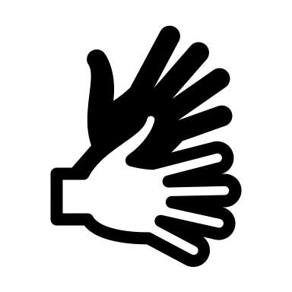Languages: Staff speak English, Mandarin, and limited Cantonese. ASL interpretation is available for online meetings if requested.

Other Notes: There is filtered water available and cups. There is a first aid kit in the space. There is a naloxone kit on the third floor accessible via Tett Centre staff.

Summary of Access Notes (Short Version)

Transportation and Parking: There are four accessible parking spots and many spots that are not designated as accessible. There is a bus stop across from the Tett Centre.
More information, photos, and image descriptions are below in the detailed access notes.

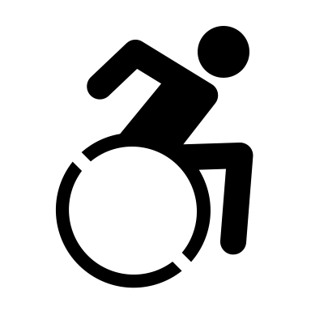Wheelchair Access: The Kingston Arts Council space is accessible for most wheelchair users. The door remains open during operating hours unless there is a confidential meeting. There are no mats or barriers in the space. The gallery does change but there is always a sufficient barrier-free path to the main space. There is wheelchair access throughout the Tett Centre building. More information, photos, and image descriptions are below in the detailed access notes.

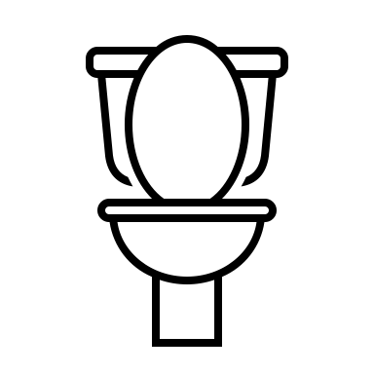Washrooms: There are washrooms on each floor of the Tett Centre. There are three sets near the Kingston Arts Council. Coming out the door of the Arts Council, to the left, there is a gender neutral, single stall washroom with grab bars, a large bench that can be used as an adult size change table, space under the sink, and two cords for emergencies. There are no automatic buttons for the doors.

To the right there are gendered washrooms with multiple stalls. More information, photos, and image descriptions are below in the detailed access notes.

Sensory Notes: There is currently no low sensory space inside the Kingston Arts Council or in the Tett Centre, however the Kingston Arts Council office is usually fairly sensory-friendly. There is no music (though they are happy to put some on if guests prefer), there are usually only two staff in the space, and zero to five other people maximum. Occasionally at a reception or opening, there may be more people in the space. There is a fan that turns on and off that does make some sound. The lighting in the gallery entry space is LED softer lighting and in the main space it is fluorescent lighting with natural light from the windows.

Contrast/Textures: There is some visual contrast in the space. The floors and wall are different colours and there is artwork on the walls. The entry or gallery space changes. The floor is concrete.

Scent policy: We encourage the use of unscented products though we cannot guarantee that we are 100% scent free.

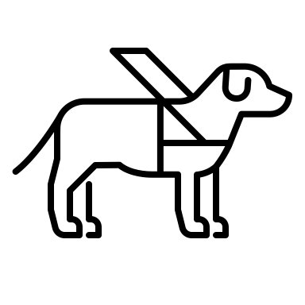Service animal policy: We welcome service animals and have water bowls. It is common to encounter animals in the space.

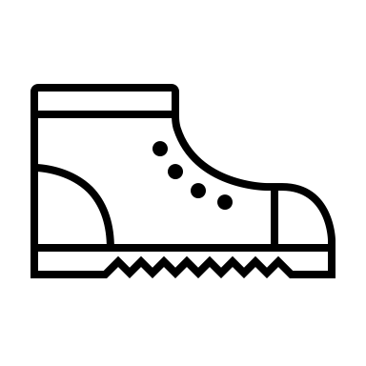 Shoe policy: There is no shoe policy. People typically keep their shoes on though people are welcome to do whatever is comfortable.

Additional Notes: In addition to water, there is a mini fridge, microwave, coffee pot, and printer available for use. Drop ins are welcome.

Questions/Feedback: We welcome accessibility questions and feedback. We have a drop box outside of our door. It is across the hall on the left. You can leave us a note or contact Nicole via email ed@artskingston.ca or phone 613-546-2787.

Detailed Access Notes with Photos and Descriptions

Parking

There are two parking lots at the Tett Centre. The first is on the right after you turn into the Tett Centre complex. There are four free accessible parking spots for visitor use. The numbered spots are for tenants.

The second parking lot is past the Isabel Bader Centre. There are many spots, both accessible and not. This is paid parking. Note: it is down a hill.

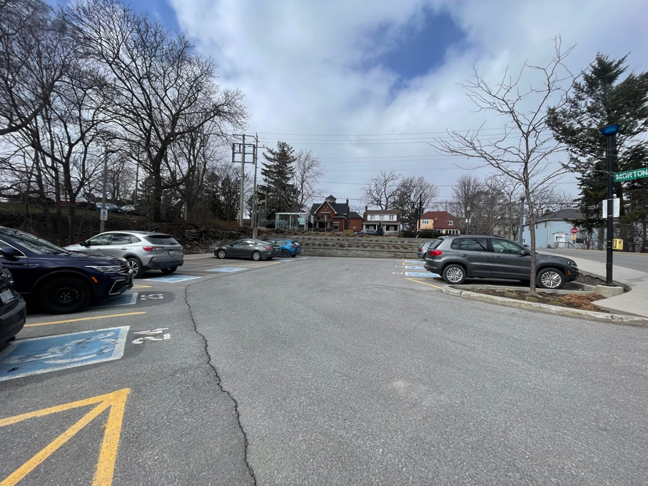
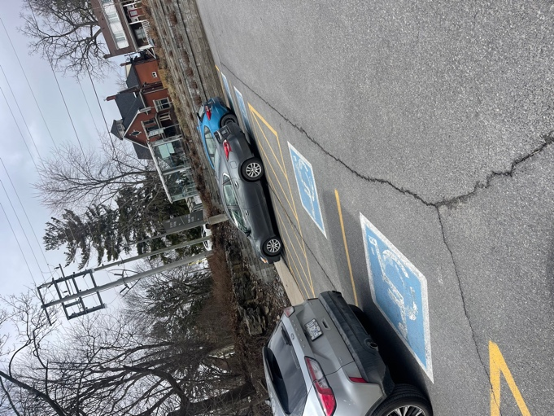

Images: two photos of the parking lot in front of the main door to the Tett Centre with four accessible parking spots and several numbered parking spots for tenants.

Path To Second Parking Lot

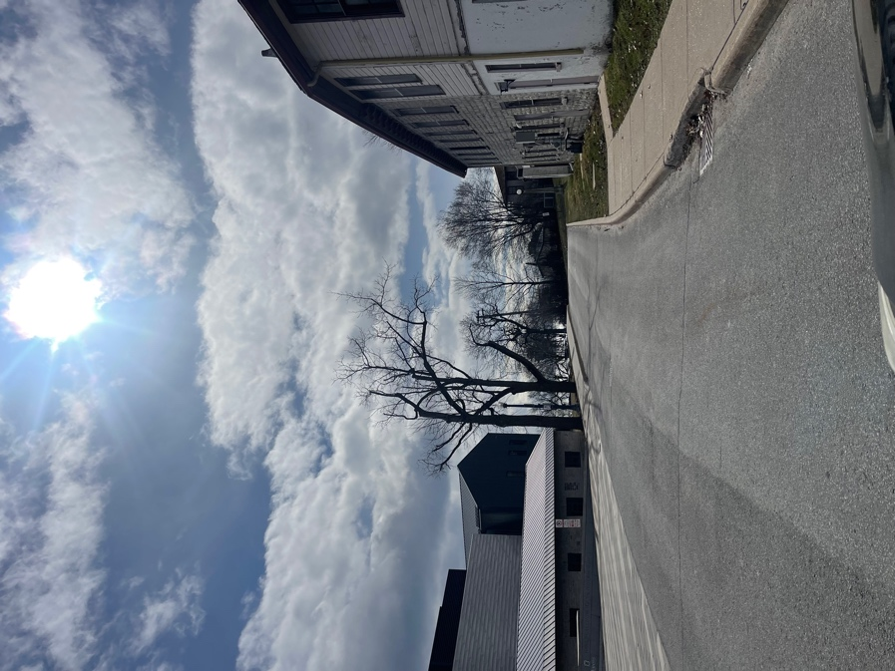
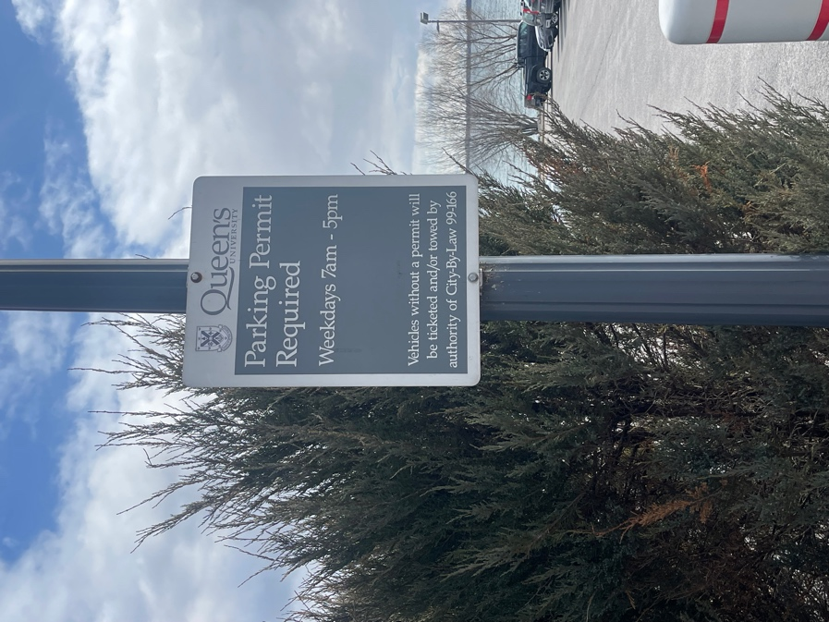

Images: 1. A photo of the road that continues past the main door to the Tett Centre and past the Isabel Bader Centre to the second parking lot. 2. A photo of the sign in the parking lot that says Parking Permit Required weekdays 7am – 5pm.

The second parking lot with both accessible parking spots and spots that are not designated.

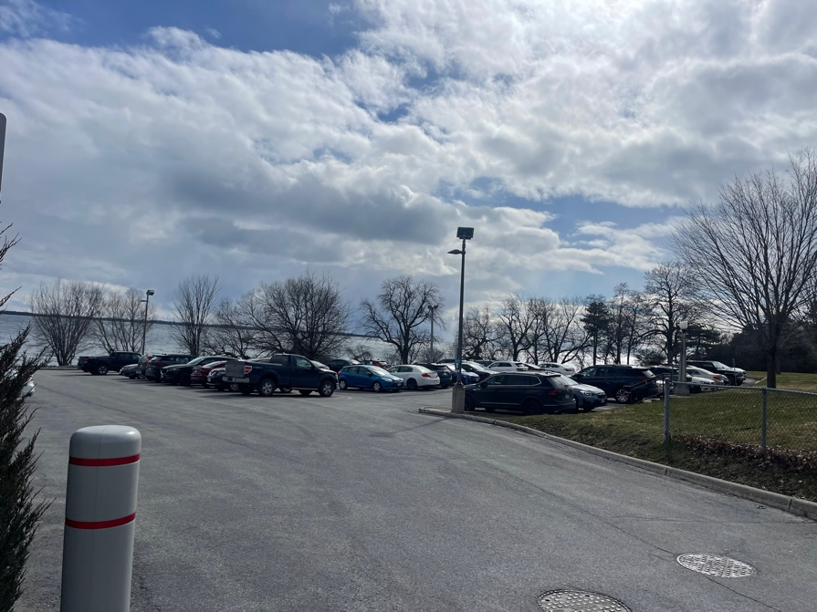
Image: a photo of the parking lot with Lake Ontario behind it.

Public Transportation:

There is a bus stop just outside of the Tett Centre/Isabel Bader Centre complex. The buses are routes 3, 501, and 502.
To plan your route, visit cityofkingston.ca/residents/transit/bus-schedules
From the bus stop, turn right into the complex and the Tett Centre is the first building on the left.
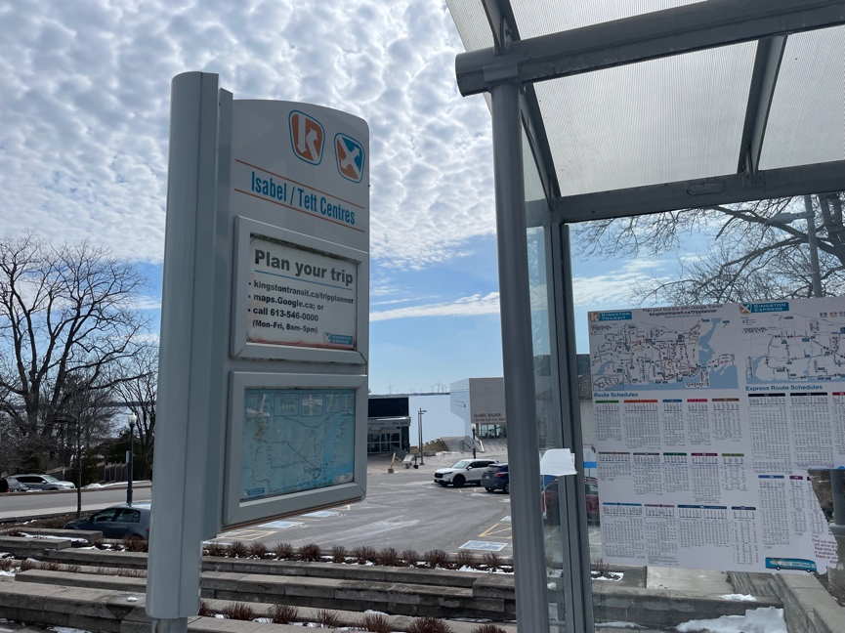

Image: a photo of the bus stop and shelter that is direcly in front of the Tett Centre on King Street.

Entrance of Tett Centre

There are two entrances to the Tett Centre.

Lakeside Entrance
This entrance is most easily accessed from the second parking lot. There is a path along the water of interlocking bricks that goes to the entrance. There are automated buttons on the doors. There is a planter at this entrance however there is 127cm or 50 inches of clearance. There are no other barriers. The door width is 95cm or 30 inches and it opens out. There are turn handles. This entrance tends to be busier as Juniper Cafe is located inside to the right and there is a patio outside at this entrance for the cafe. There is a defibrillator inside the lakeside entrance on the left wall.

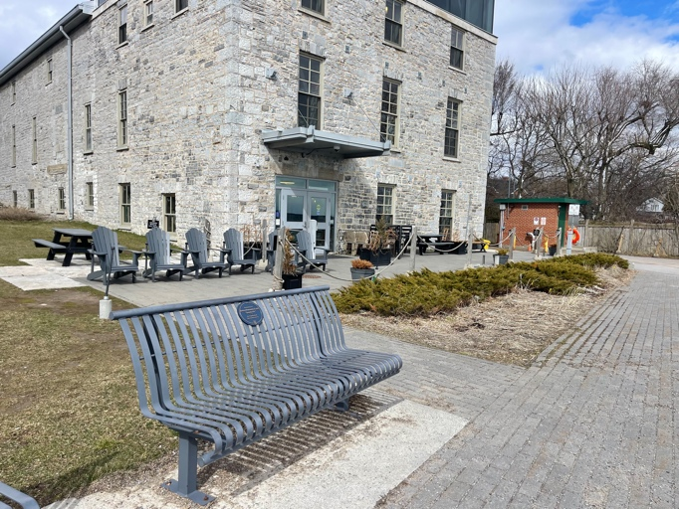

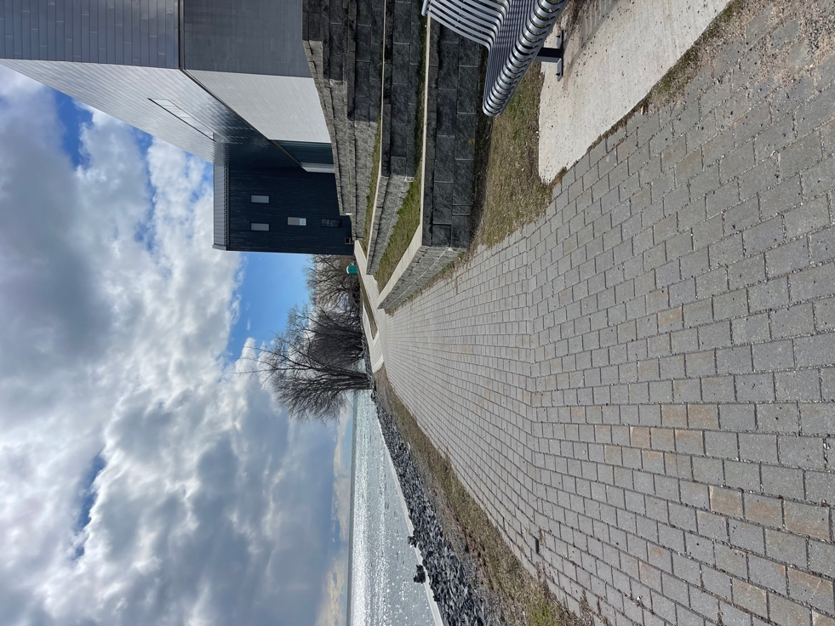

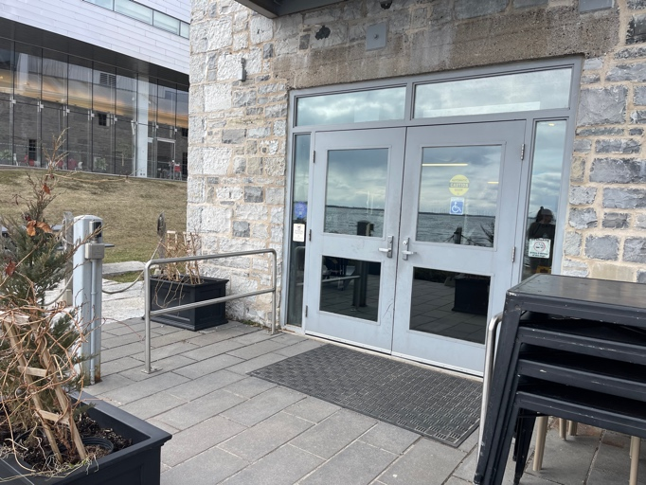

- Main Entrance

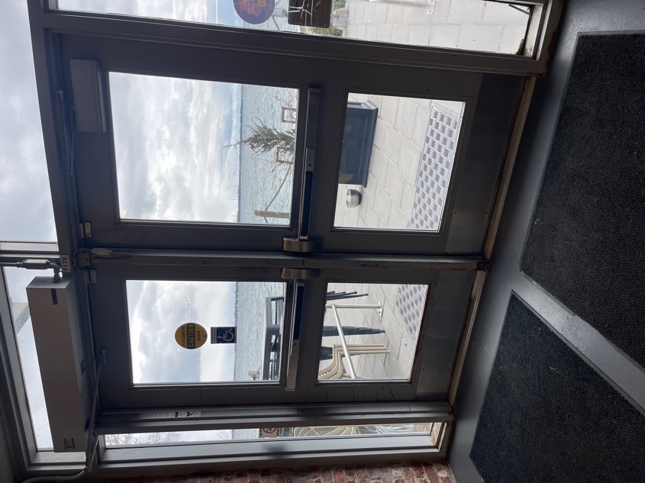
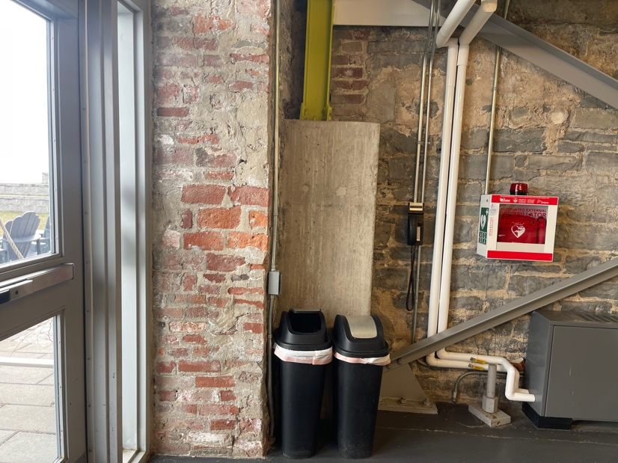

Images: 1. The interlocking brick path from the parking lot to the Lakeside entrance. 2. The Tett Centre from the Lakeside entrance. There is a bench along the path before the Tett Centre and just outside of the building there are chairs and the Juniper Cafe patio. 3. The Lakeside entrance doors. There is an automated button on the left if you are facing the doors and there is a planter with clearance for most people and mobility devices. The doors open out. 4. The Lakeside entrance doors from the inside. The automated button is to the right if you are facing the doors or there are push handles. 5. Also to the right of the Lakeside entrance doors inside the building there is garbage and recycling, and a defibrillator.

Main Entrance
This entrance is most easily accessed from the bus stop, the accessible parking lot, and King Street. The doors are automated and slide open with 179cm or 69 inches of clearance (width). There are no barriers at this entrance.
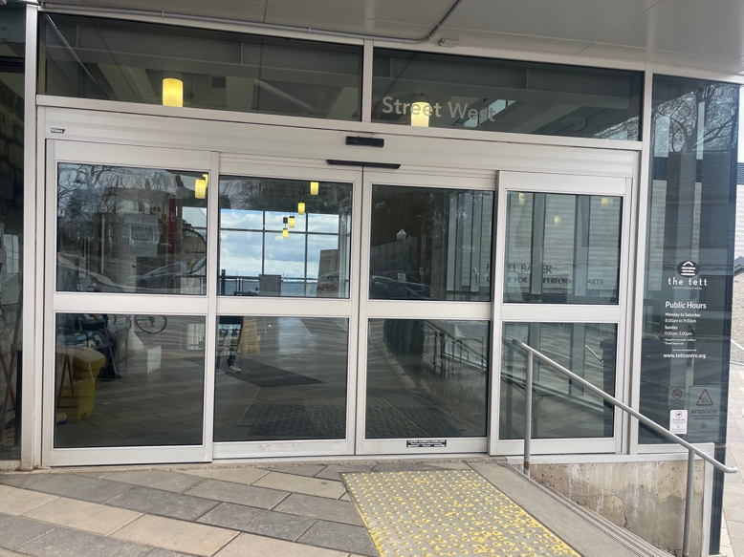

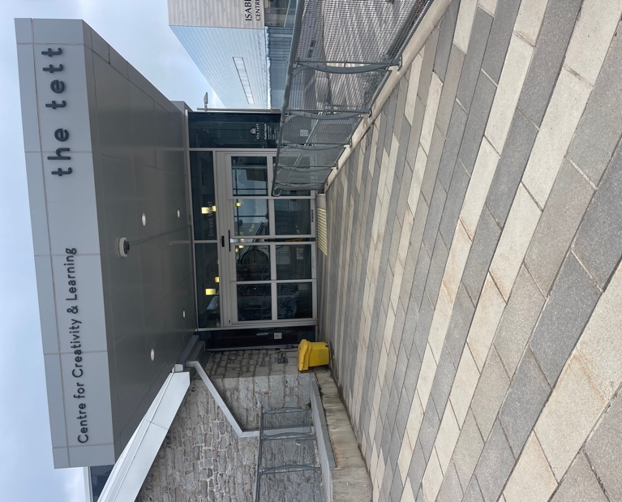

Images: two photos of the main entrance to the Tett Centre. The doors slide open and closed and are automated. Outside, to the right of the doors is a staircase with a railing that goes towards the Isabel Bader Centre.
Directions upon entering:

From the lakeside entrance:
After entering the doors, the Kingston Arts Council is the third door on the right (after the cafe and the accessible gender neutral washroom).

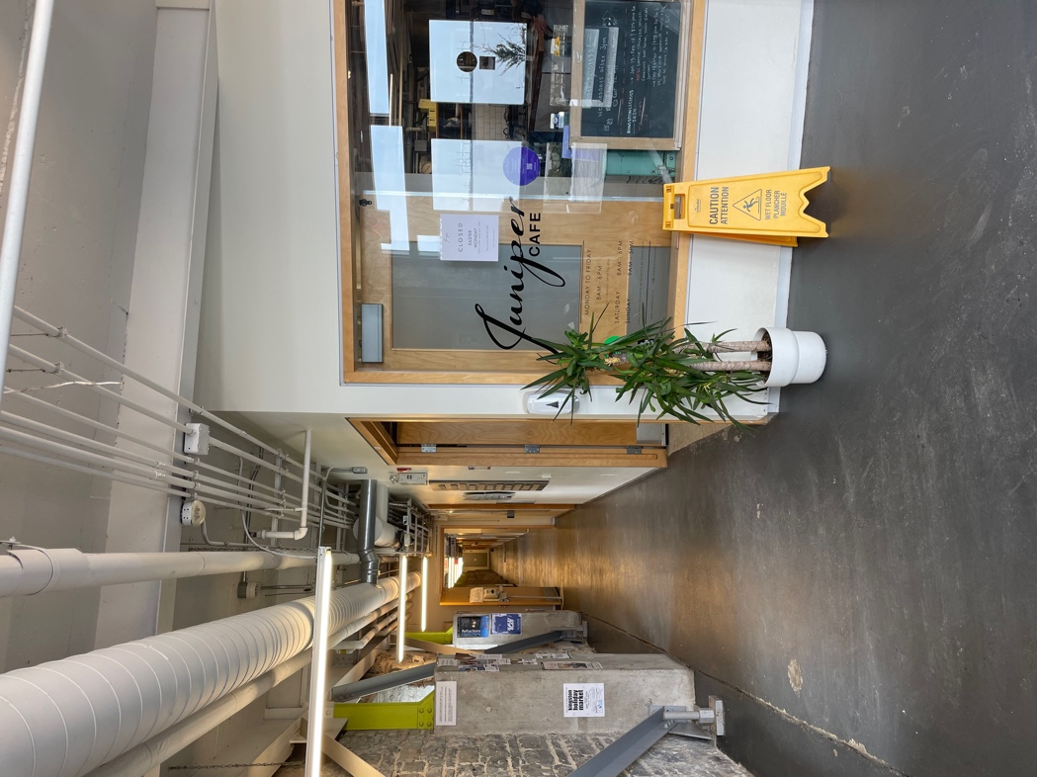

Image: Inside the Lakeside entrance to the right is Juniper Cafe. The hallway straight ahead leads to the Kingston Arts Council.

From the main entrance:
- After entering the doors, go straight past the door and then turn left. There is an automatic button to open the door. Through the door is the elevator. In the elevator go down two floors to the first floor. Turn right when you come out of the elevator and follow the hallway. Kingston Arts Council is Unit 115 on the left. It is almost at the end of the hall. If you reach the accessible washroom or Juniper Cafe, it is behind you.

- The other option is to take the stairs which are located on the left inside the main entrance. At the bottom of the stairs, enter the door on the left then turn right and follow the hallway to unit 115 on the left.

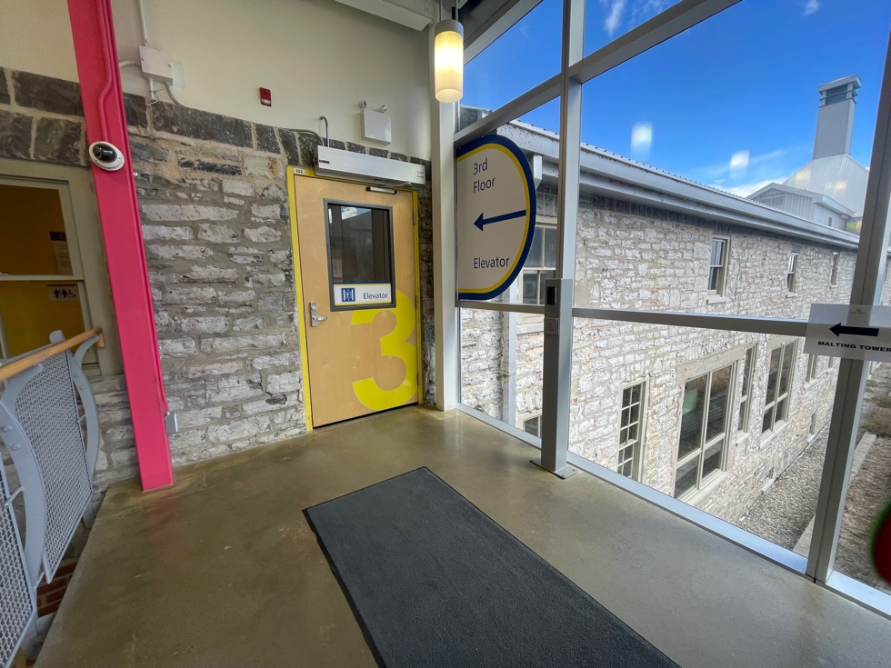

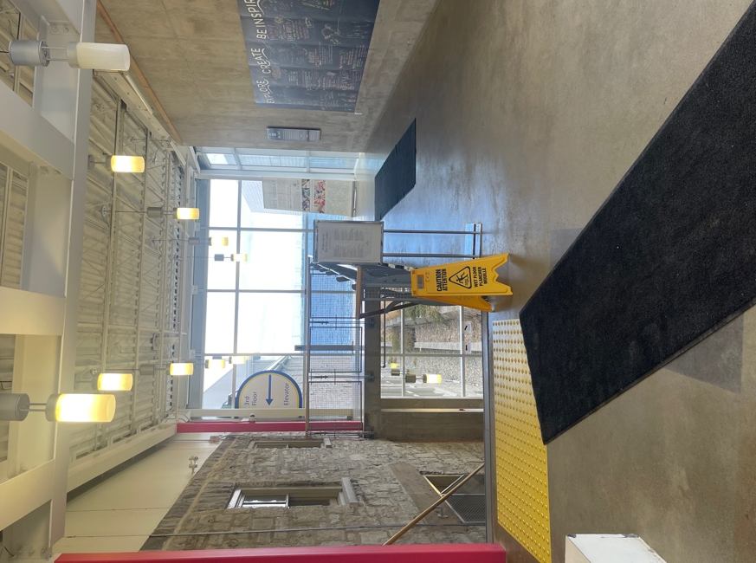

Images: Two photos inside the main doors. On the left side is the stairway with a railing on both sides and on the right side is the path to the elevator. The second photo is the door to enter for the elevator which is on the left.

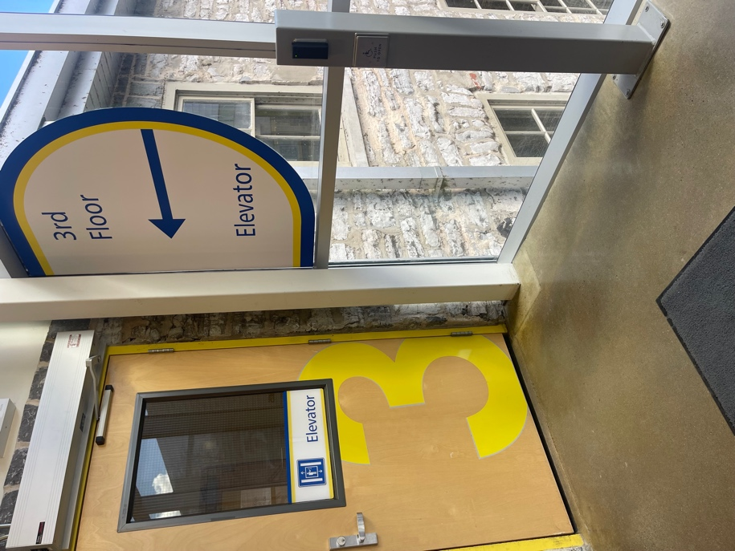
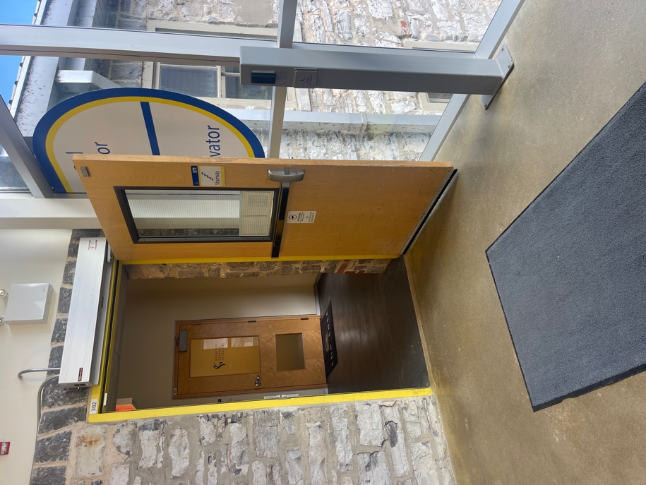

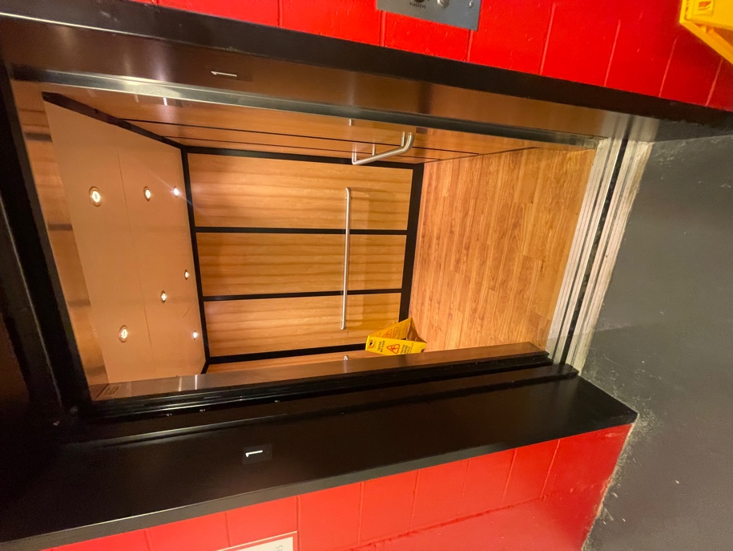
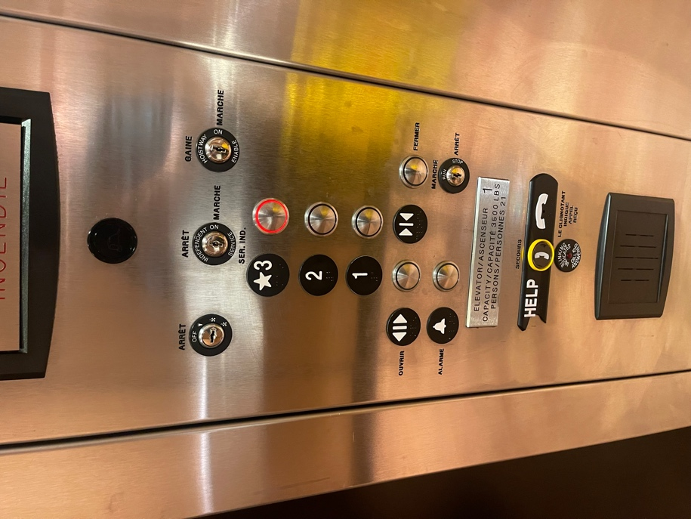

Images: 1. The door to the elevator with the automatic button on the right. 2. The open door to the elevator. 3. The inside of the elevator with railings on all sides. 4. The buttons in the elevator. Options for the first, second, and third floors. The Kingston Arts Council is on the first floor.

Entrance of Kingston Arts Council

The door to the Kingston Arts Council is typically open unless there is a confidential meeting, or it is requested. The door has a turn handle and opens in. It is 93 cm or 37 inches wide.

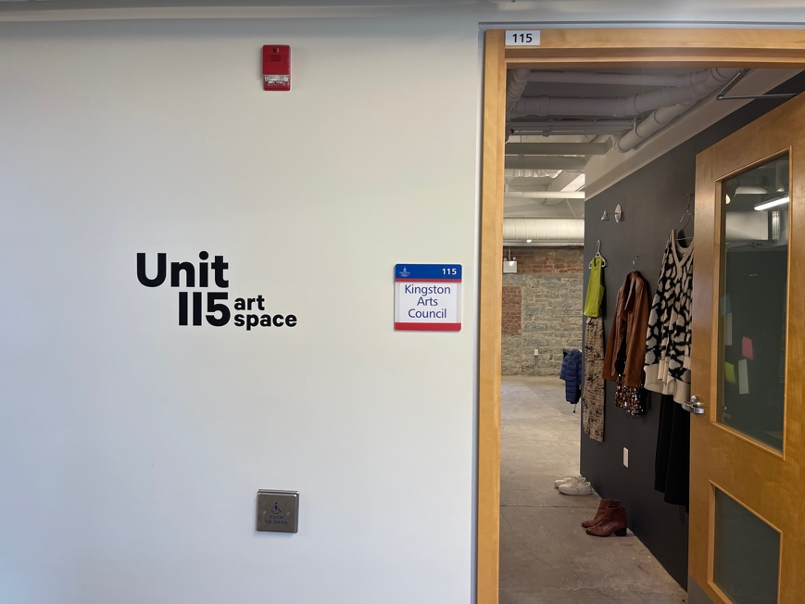
Inside the door is the gallery space. The installations are always changing but there is always a clear path at least 93cm or 37 inches wide to the main space. The lighting in the gallery is dim LED ceiling lights.

Across the hall from the entrance is a drop box for feedback. It is on the left if you are leaving the Kingston Arts Council.

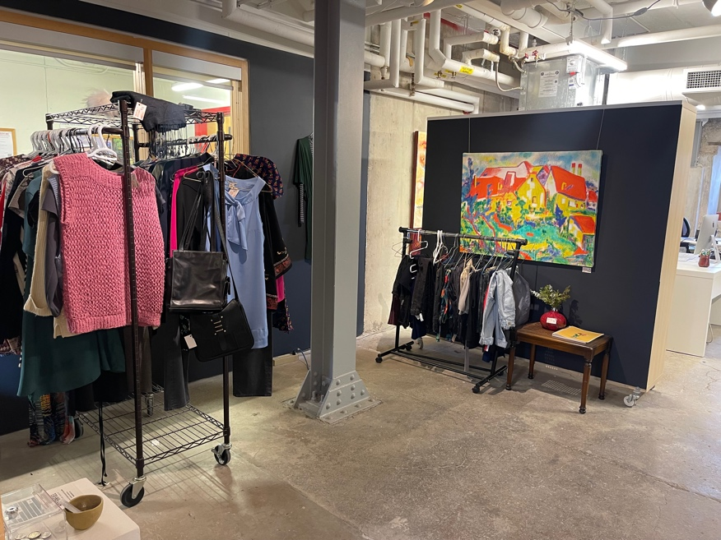
Images: 1. The entrance to the
Kingston Arts Council. On the
wall to the right of the door, it
says Unit 115 art space and
there is a Kingston Arts
Council sign. The door opens
in. 2. The gallery space inside
the entrance to the Kingston
Arts Council. This space
changes. There is
currently clothing set up on
racks and artwork on a wall.

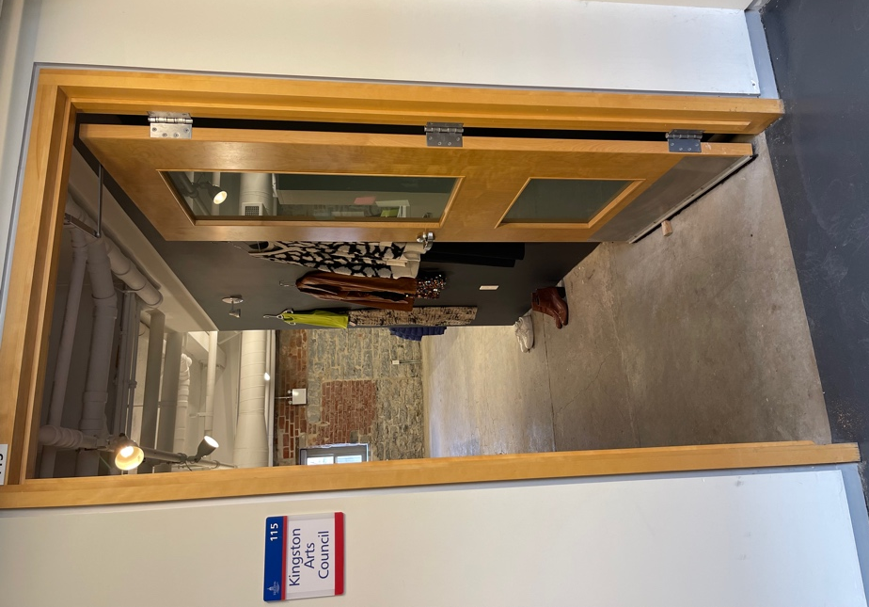

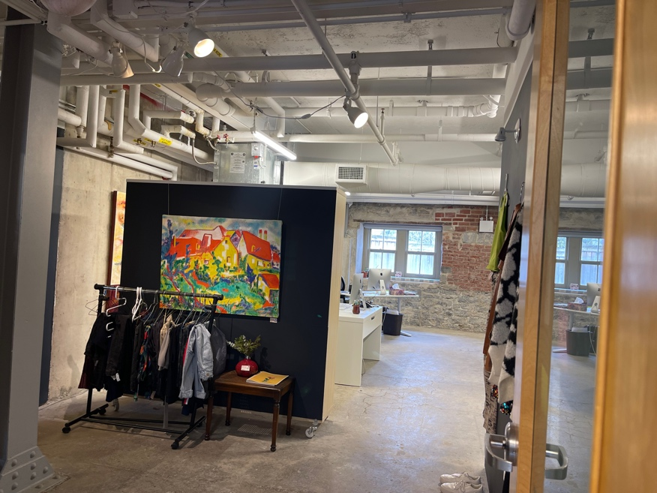

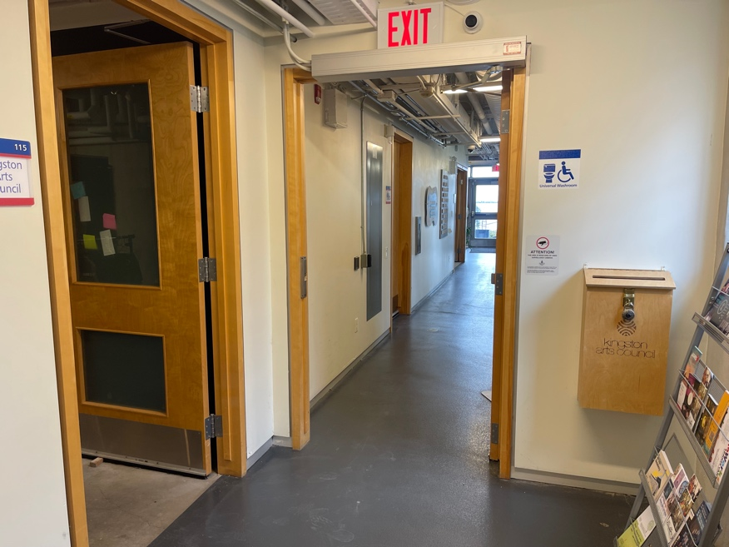

Images: 1. The doorway and
unobstructed path inside the
Kingston Arts Council. 2. The
Gallery space and
unobstructed path to the office.
- Outside of the Kingston
Arts Council. The drop box is
across the hall on the left as
you exit.

Main Space Inside Kingston Arts Council

The floor is grey concrete, and the walls are white. There is a table on the right side of the space as you enter. There is an air conditioning system in the summer and heater in the winter with a fan that makes some intermittent noise. The space is usually quiet with no music playing (unless requested). The only other sounds are traffic in the hall.

The fire alarm is both auditory and visual. The pull system for the fire alarm is outside of the Kingston Arts Council. There are two ways out: the main entrance and the windows (in case of emergency). The Tett Centre building is largely made of limestone.

The lighting in the main area is fluorescent ceiling lights and natural light from the windows. At the back of the space from where you enter is a desk on either side for staff.

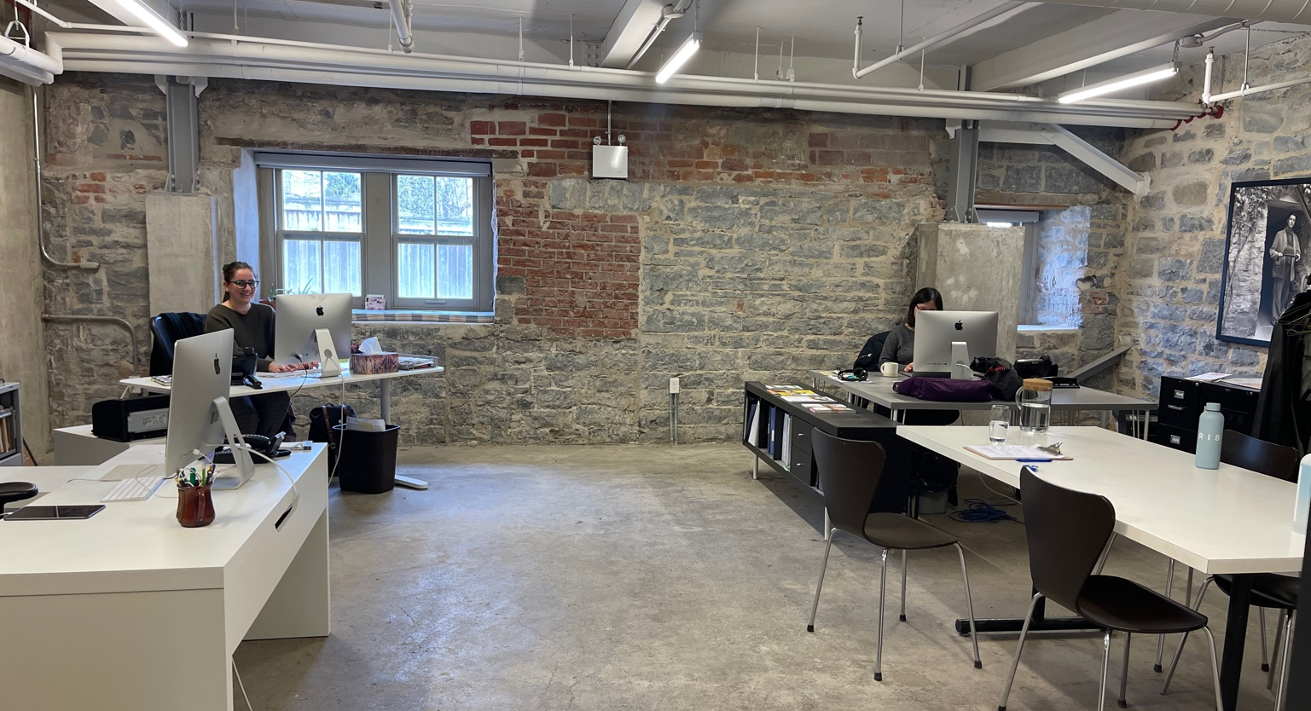

Image: the office and main space inside the Kingston Arts Council. There is a table to the right and a desk on the left. At the back there are two desks with staff working.

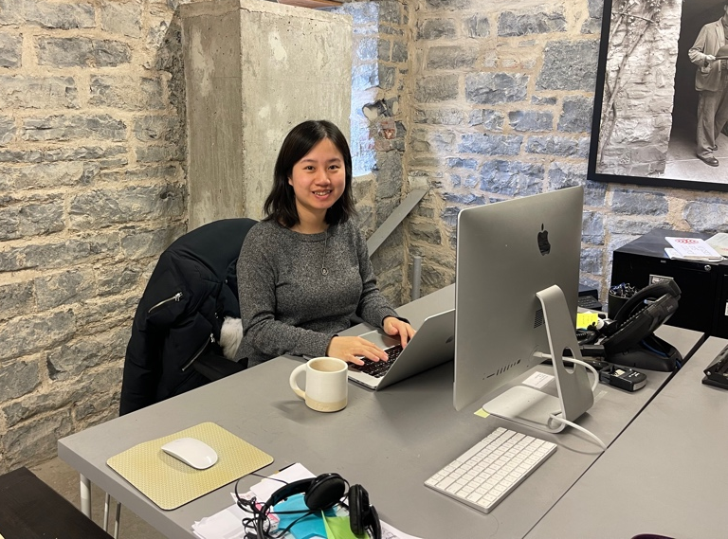
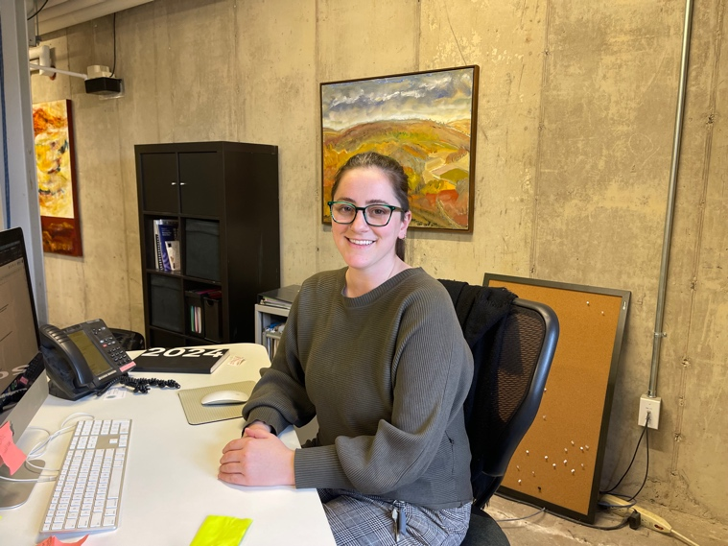

Images: 1. Nicole Daniels (she/her), a white cis woman, sitting at her desk. Nicole has brown hair pulled back into a messy ponytail, and wears her favourite emerald green glasses. 2. Violet Tang, a Chinese Canadian genderqueer person, an arts and cultural professional, a history student, and a writer, is sitting at her desk. She is the Grants and Programs Coordinator at the Kingston Arts Council.

Bathroom
There are three bathroom options on the first floor.

- Gender neutral, “universal” washroom: Exiting the Kingston Arts Council, turn left and then left. This is a single stall washroom with horizontal and vertical grab bars beside the toilet and a horizontal bar behind. There is a large bench that can be used as an adult size change table, space under the sink, and two cords for emergencies, one is located to the right of the toilet if you are on it and the other is behind the bench on the opposite wall. The toilet is an automated flush system, but the censor is blocked by the toilet seat lid. Close the lid and wait for the sensor to activate or use the silver button beside the censor to manually activate the flush.

The door is 98cm or 38.5 inches wide. There are no automatic buttons. The door opens in and there is a turning handle. There is a push lock on the interior door handle, which unlocks when you turn the handle to exit.

There are no menstrual products in the washrooms however tampons are available at the Kingston Arts Council and the Tett Centre also has some menstrual products in their access kit in their office. There is space under the sink and the mirror is long and starts just above the sink. The soap is a liquid manual dispenser and is within reach of someone who is sitting (depending on the situation).

There is a fluorescent light above the mirror. The manual paper towel dispenser is also within reach of someone who is sitting (depending on the situation).

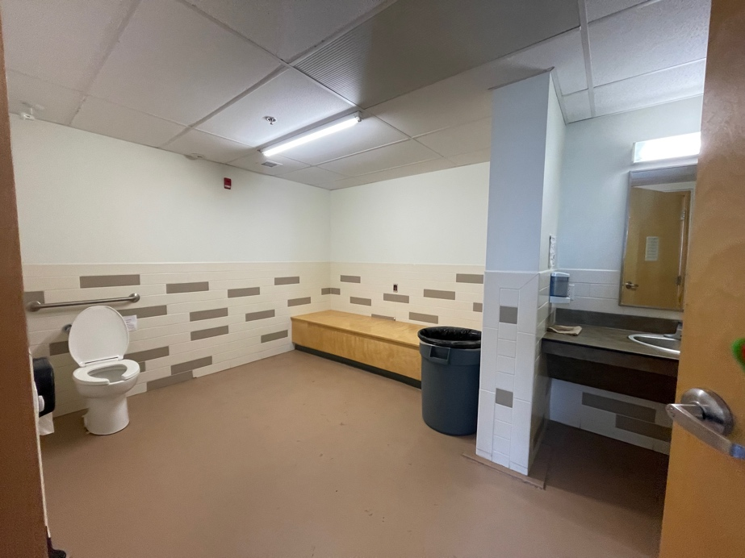
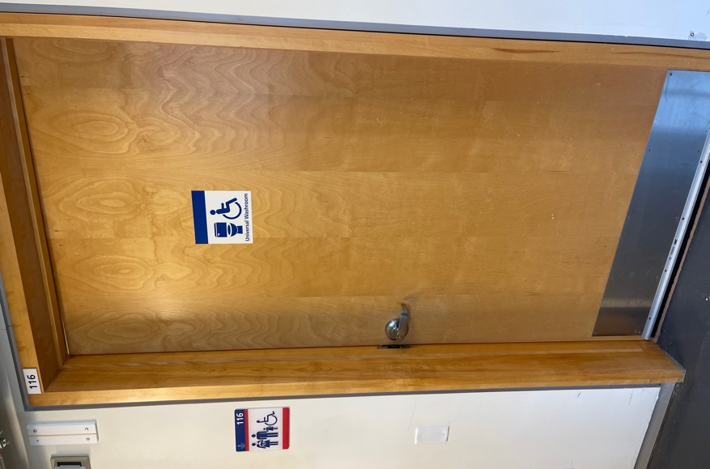

Images: 1. The door to the universal bathroom from the outside. The door opens in with a turn handle. The sign has the accessibility sign and a toilet on it. 2. Inside the universal bathroom. The toilet is on the left. The bench or changing table is to the right of the toilet and the sink is straight ahead after entering the door.

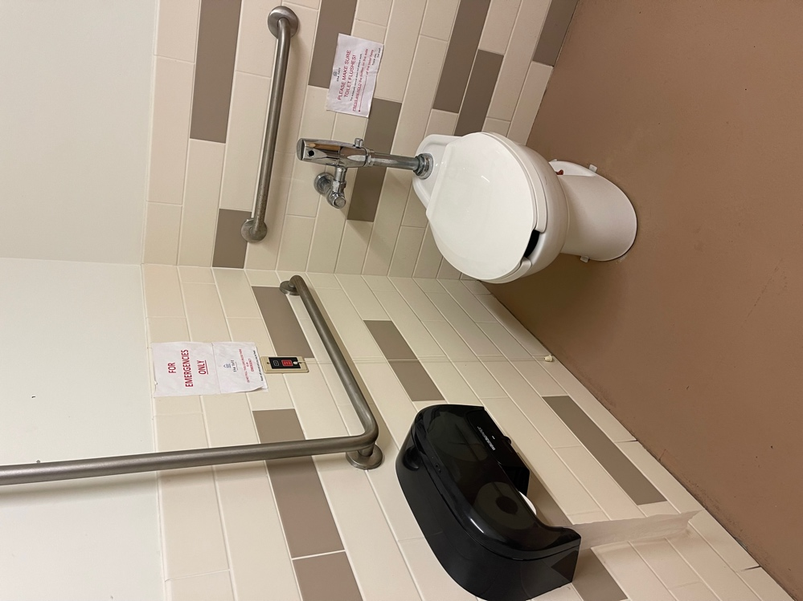
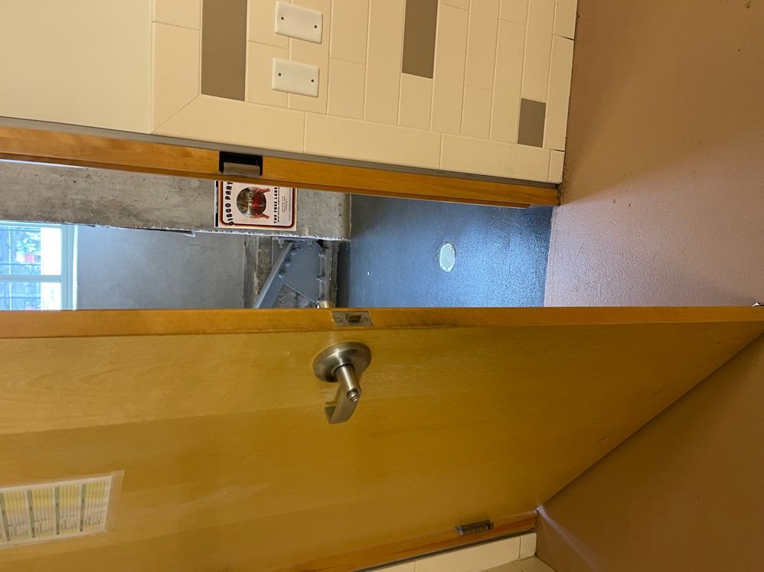

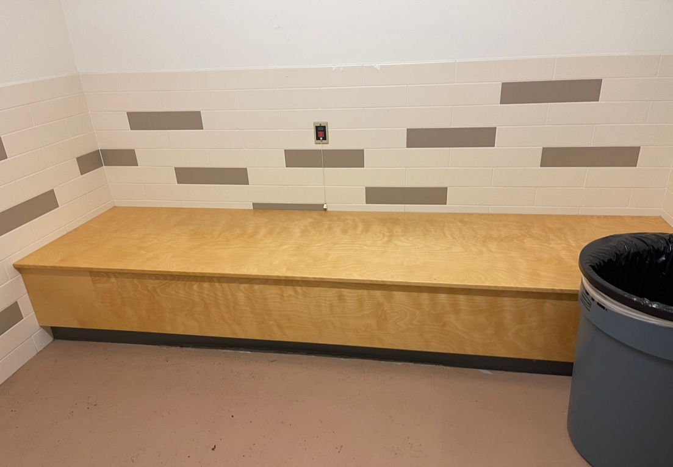

Images: 1. The door to the universal bathroom from the inside, opening in. 2. The toilet with a horizontal and vertical grab bar to the right if you are on the toilet and a horizontal bar behind it. The toilet paper is on the right from the toilet. 3. The bench and the emergency pull string on the wall behind it.

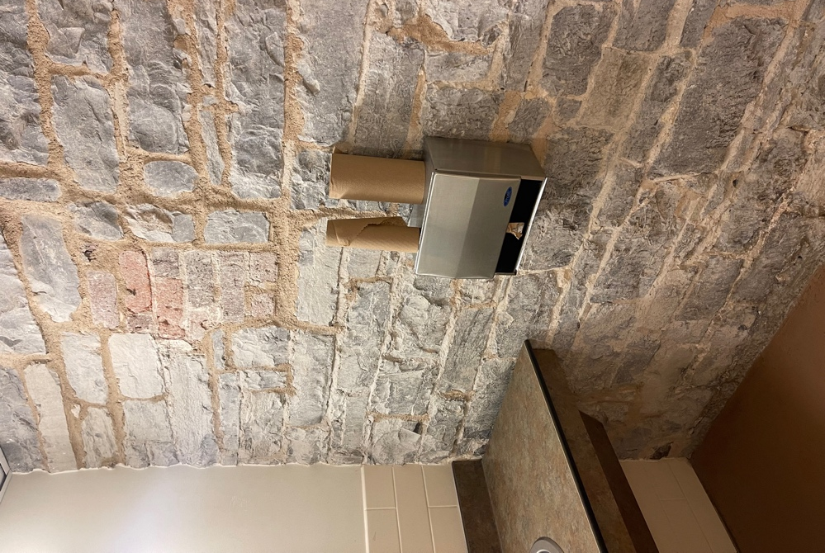
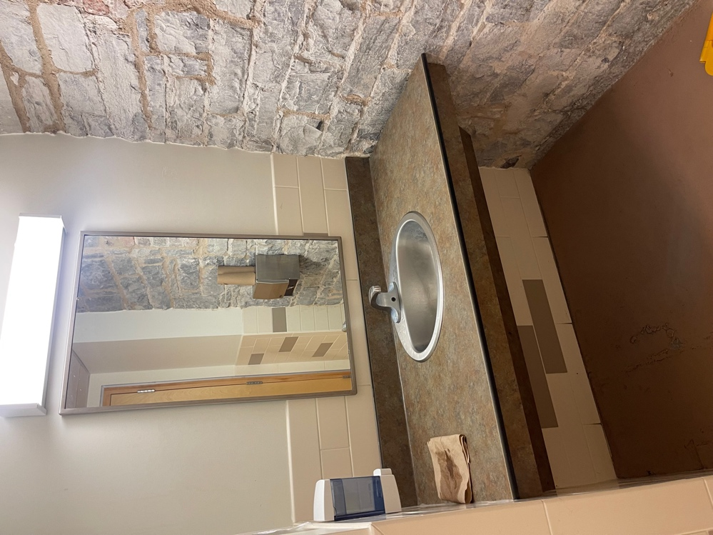

Images: 1. The paper towel on the right wall if you are facing the sink. 2. The sink which is automated and the low mirror with the manual soap dispenser on the left wall if you are facing the sink.

- The women’s washroom is located to the right when you exit the Kingston Arts Council. It has three stalls, two sinks, and space under the sinks. The mirror is long and starts just above the sink. The soap is a liquid manual dispenser and is higher than in the universal washroom, as is the manual paper towel to the right of the sinks.

The door is 93 cm or 37 inches wide.

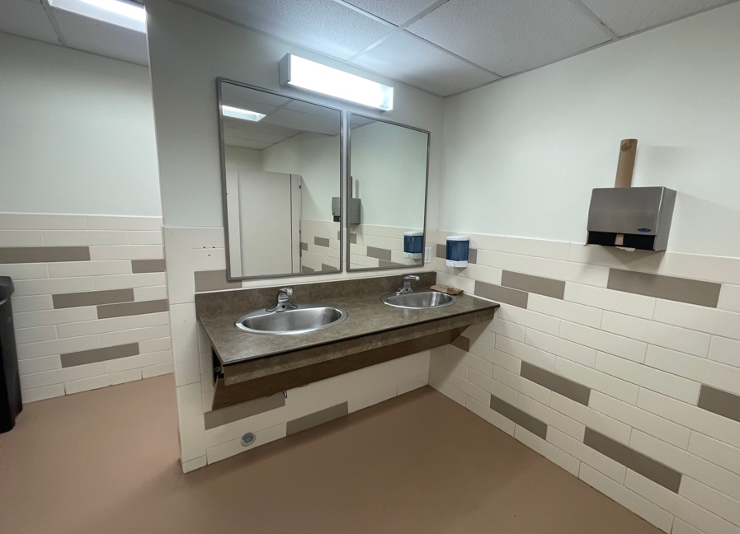

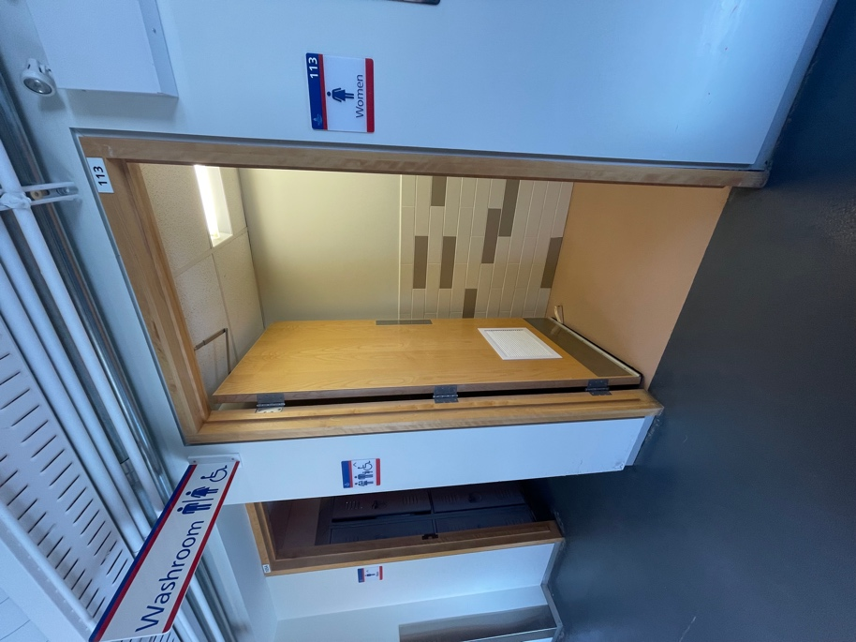

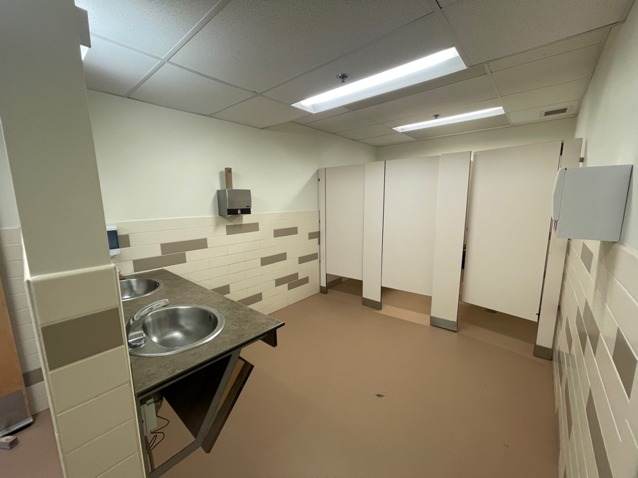

Images: 1. The entrance to the
women’s washroom. The door
opens in and stays open. 2. Two
sinks inside the women’s
washroom with space underneath, low mirrors, and a higher paper towel dispenser than the universal washroom. It is on the right wall if you are facing the sinks. 3. The three stalls directly across from the sinks.

- The men’s washroom is located to the right when you exit the Kingston Arts Council and down a hall to the right. It has two smaller stalls, and a urinal. It has two sinks and space under the sinks. The mirror is long and starts just above the sink. The soap is a liquid manual dispenser and is higher than in the universal washroom, as is the manual paper towel to the right of the sinks.

The door is 93 cm or 37 inches wide.

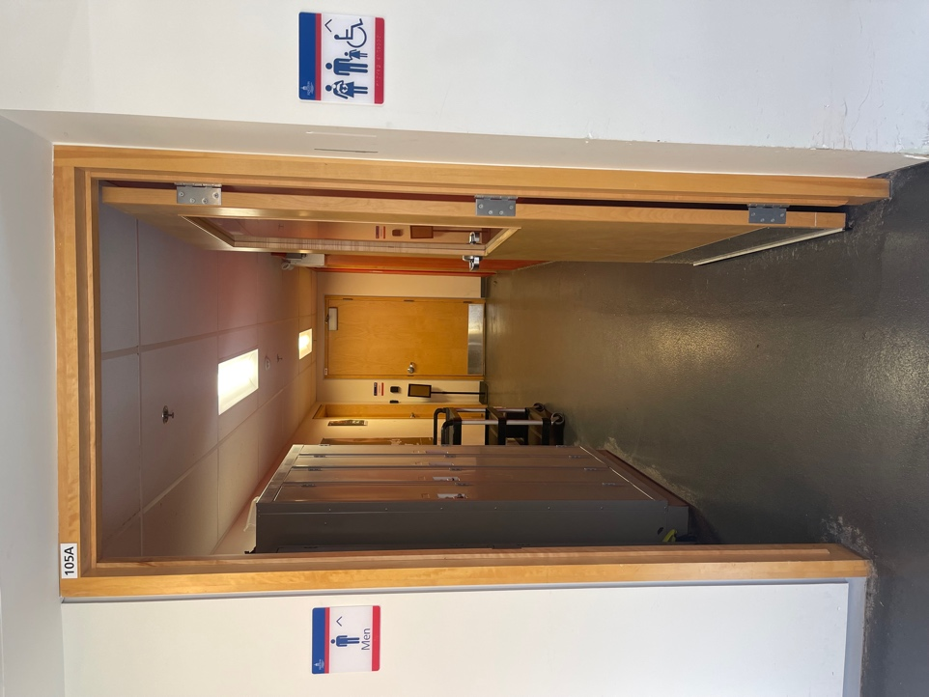
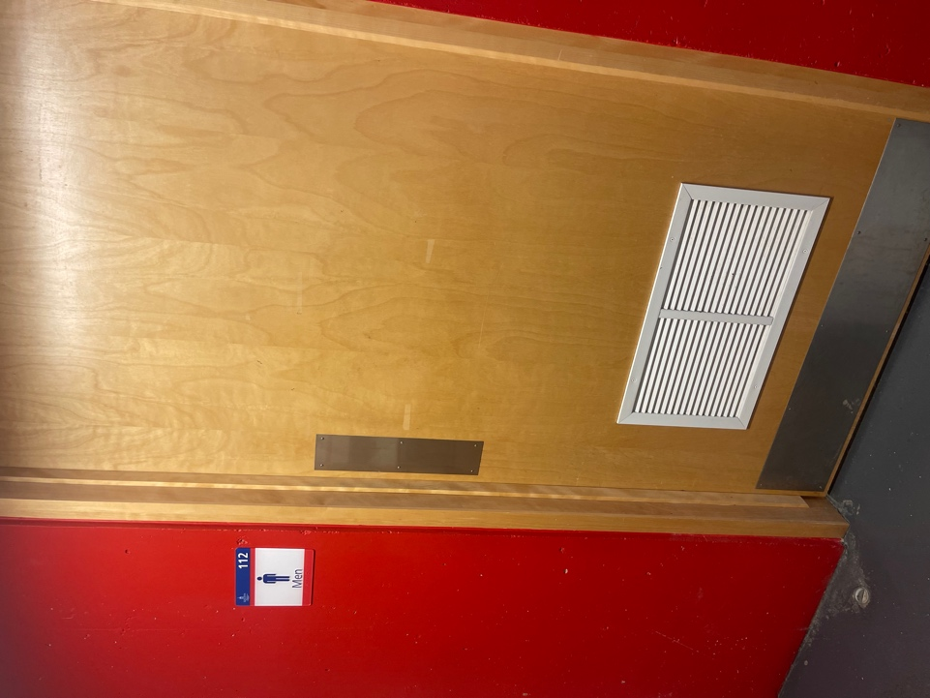

Images: 1. The hallway to the men’s washroom. It is on the right at the end of the hall. 2. The door to the men’s washroom that is a push door that opens in.

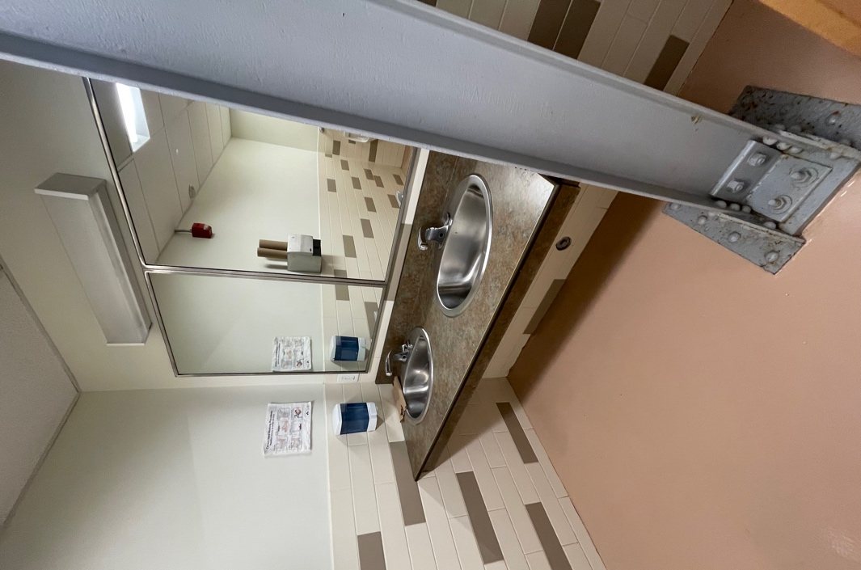
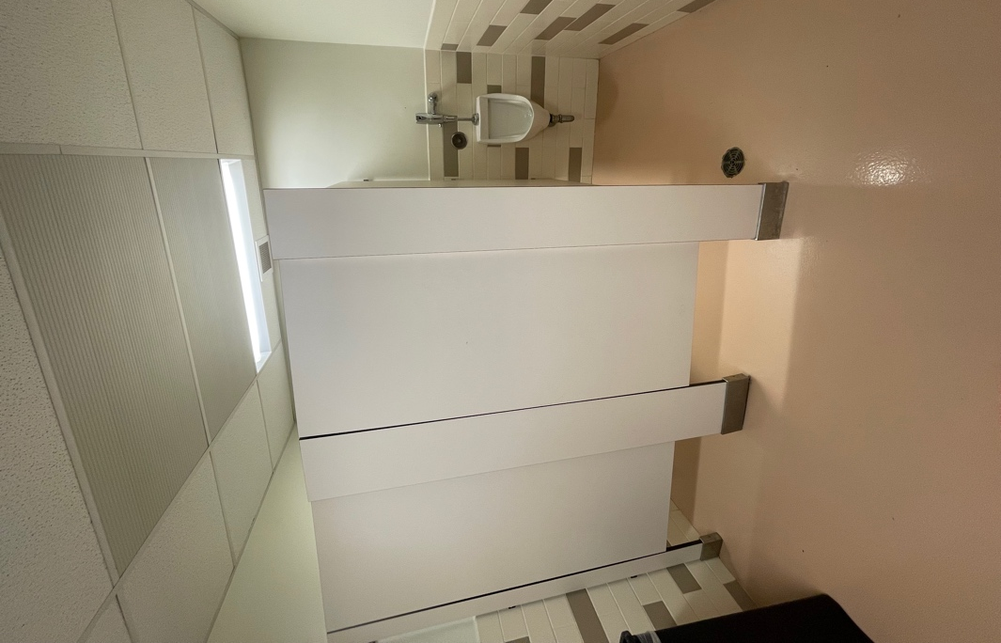

Images: 1. Two stalls on the left after you enter the washroom, and the urinal is on the right. 2. Two sinks with low mirrors. The manual soap dispenser and manual paper towel dispenser are the left wall.

Fire Exits

There are several exits from the Kingston Arts Council. As mentioned above, there are two ways out of the space (the door and the windows). To get outside of the building from the door, the lakeside exit is to the left. There is also a fire exit on the right. The stairwell exit (or fire exit, although it can be used as an exit anytime, just not an entrance) does not have an automatic door opener. It also opens to a small stairwell outside: three concrete steps with handrails.

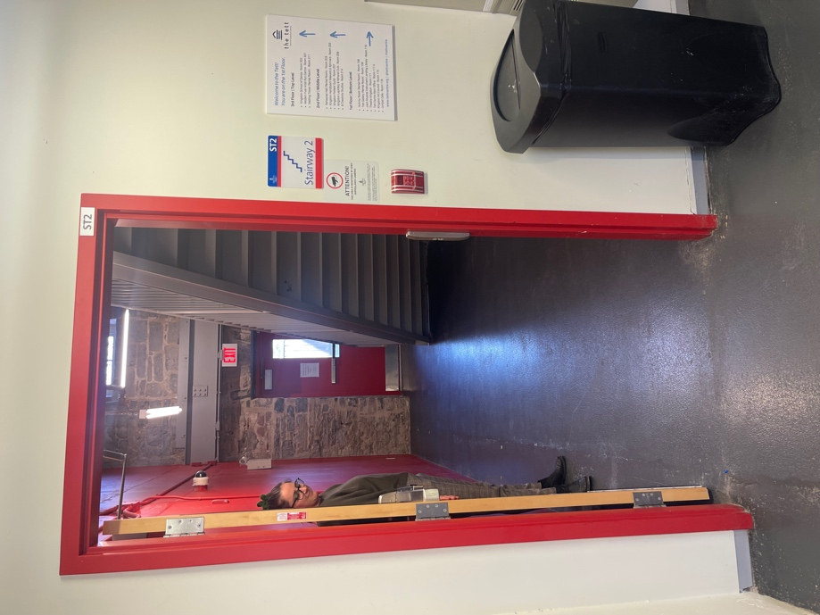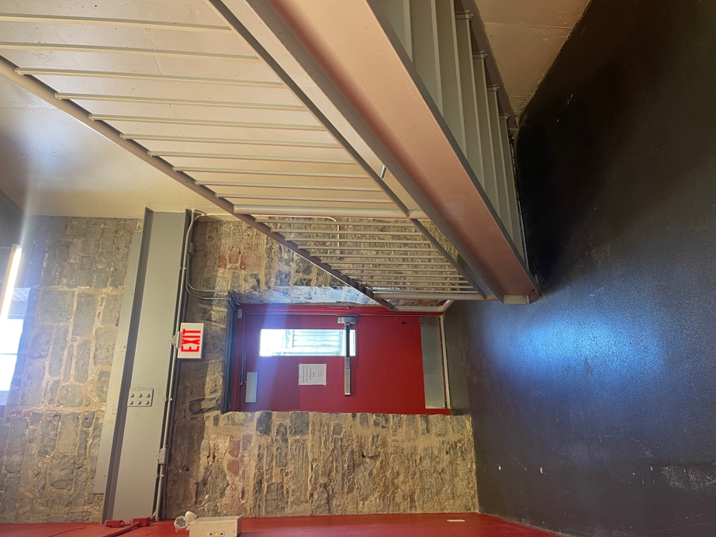

Images: 1. A door before the fire exit door or alternate exit from the building. The door opens out from the inside. 2. The fire exit or alternate exit door with a stairway with a railing on the right. The door is a push handle and it opens out.

